**INFO 5707 Data Modelling - Term Project**

**Pet Adoption Hub using MySQL**

**Team Coordinator:** Jayavardhan Reddy Samidi

**Team Members:**

Sri Sai Durga Katreddi

Vardhan Gattu

**OBJECTIVE:**

* To manage the data related to a pet shelter, including pets, staff, veterinarians, donors, fosters, adoption applications, and medical records.
* To allow for easy tracking and management of pets in the shelter, including their breed, age, gender, and location.
* To facilitate communication between staff, veterinarians, and fosters to ensure the best care for the pets.
* To track donations from donors and manage the donation history of each donor.
* To manage adoption applications and track the status of each application.
* To track medical records for each pet, including vaccinations and treatments.

**SCOPE:**

* The database will be used to manage data for pet shelters.
* The database will include tables for pets, staff, veterinarians, donors, fosters, adoption applications, and medical records.
* The database will allow for easy tracking and management of pets in the shelter, including their breed, age, gender, and location.
* The database will include functionality to manage communication between staff, veterinarians, and fosters to ensure the best care for the pets.
* The database will track donations from donors and manage the donation history of each donor.
* The database will manage adoption applications and track the status of each application.
* The database will track medical records for each pet, including vaccinations and treatments.

**USER REQUIREMENTS:**

* The shelter staff should be able to view and manage information about the animals in their care, including their names, breeds, genders, ages, and medical records.
* Foster volunteers should be able to view information about the animals they are caring for, as well as manage their own information and availability.
* Donors should be able to make contributions to the shelter and view information about their past donations.
* Adoption applicants should be able to submit applications for specific animals, and shelter staff should be able to view and manage these applications.
* Veterinarians should be able to view and manage medical records for the animals they have treated.
* Shelter staff should be able to view and manage information about the shelter's facilities, including its name, address, phone number, and staff members.
* Shelter staff should be able to assign animals to foster volunteers, and update these assignments as needed.
* Shelter staff should be able to track the status of adoption applications, and update these statuses as needed.
* Donors should be able to view information about the shelter's financial needs and make donations to specific programs or initiatives.

**CHOICE OF DBMS:**

* MySQL is an excellent option for a Pet Adoption System due to its popularity as an open-source relational database management system (RDBMS). With a large community of developers and users, MySQL is renowned for its scalability, reliability, and ease of use. Additionally, it is an ideal option for web-based applications, making it an excellent choice for a Pet Adoption System that may include an online component. Due to its integration capabilities with various programming languages, MySQL is an ideal choice for developing a web-based application.

**BUSINESS RULES:**

* 1. **Users can sign in using their login credentials and submit adoption applications for specific pets. They can view their application status and update their contact information. Users can also view their donation history, make new donations, and receive updates on pets they have adopted or are interested in. They can submit foster applications and view the status of their application. Personalized pet recommendations based on their preferences and lifestyle are also available to users with a USER ID.**
  2. **The database is designed to manage data related to an animal shelter, including information about pets, staff, donors, fosters, veterinarians, adoptions, medical records, and more.**
  3. **Each pet must be associated with specific shelter and may also be associate with a foster caregiver.**
  4. **Staff members are associated with a specific shelter and may have a title and phone number.**
  5. **Veterinarians have unique identifiers and are associated with medical records for pets they treat.**
  6. **Donors provide information about their contact details, donation date, and the amount donated.**
  7. **Fosters provide information about their name, phone number, email address, start and end dates of their fostering period, and foster status.**
  8. **Adoption applications may be submitted for specific pets, and include the applicant's name, contact details, and application status.**
  9. **Medical records include information about pets' medical treatment and vaccinations, as well as the veterinarian who provided the treatment.**
  10. **Each pet must have a unique identifier, name, breed, gender, and age.**
  11. **The database is designed to be scalable and easily maintainable, with foreign key constraints and referential integrity enforced to ensure data consistency.**

**ENTITY RELATIONSHIP DIAGRAM (ER-Diagram)**

**DATA DICTONARY:**



**DATA ENTRY AND UPDATE:**

**Create Table 1: Shelter**

**Output:**



**Create Table 2: Staff**

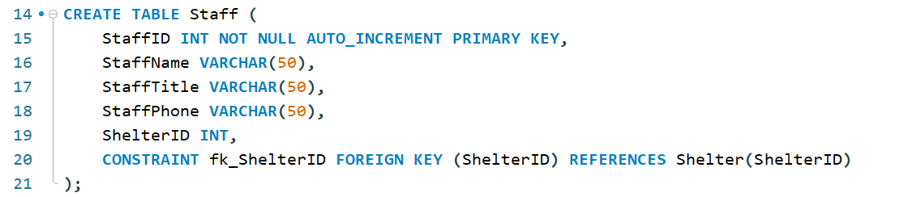

**Output:**



**Create Table 3: Veterinarian**

**Output:**



**Create Table 4: Donor**

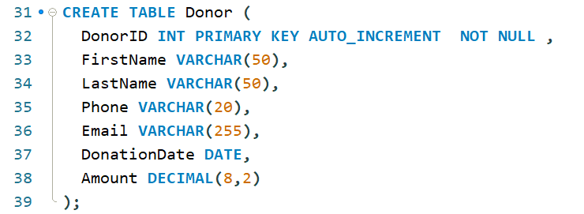

**Output:**



**Create Table 5: Foster**

**Output:**



**Create Table 6: Pet**

**Output:**



**Create Table 7: Adoption Application**

**Output:**



**Create Table 8: Medical Record**

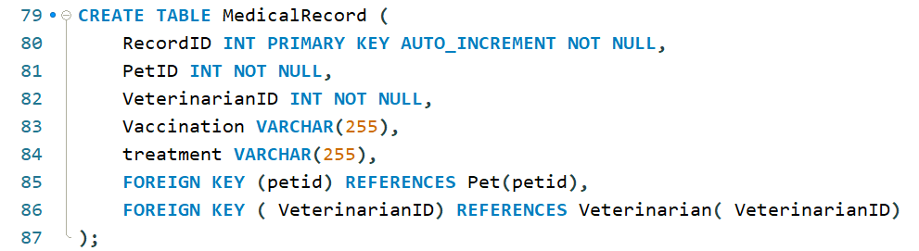

**Output:**



**INSERT RECORDS INTO TABLES**

**Insert Data into Table 1: Donor**

Output:



**Insert Data into Table 2: Shelter**

Output:



**Insert Data into Table 3: Staff**

Output:



**Insert Data into Table 4: Foster**

Output:





**Insert Data into Table 5: Pet**

Output:





**Insert Data into Table 6: Veterinarian**

Output:





**Insert Data into Table 7: AdoptionApplication**

Output:





**Insert Data Into Table 8: MedicalRecord**

Output:





**RETRIEVE FROM TABLES:**

Table 1: Donor

Output:

Table 2: Shelter

Table 3: Staff

Table 4: Foster

Table 5: Pet

Table 6: Veterinarian

Table 7: Adoption Application

Table 8: Medical Record

**SAMPLE QUERIES**

**Query 1:** Retrieve the names of all the veterinarians in the database.

SELECT VeterinarianName FROM Veterinarian;

**Query 2:** Update query to change the pet gender of a specific pet with PetID = 10:

Output:





**Query 3:** Update query to assign a Foster to a pet with PetID = 29:

Output:





**Query 4:** Delete query to remove a specific donor with DonorID = 10:

Output:





**Query 5:** Delete query to remove a pet with PetID = 300 and its corresponding medical record:

Output:





**Query 6:** Write a query to find the top 5 number of the pets that have been adopted the most number of times.

